Name
Professor
Course
Date
Neighborhood in Los Angeles
Hollywood in Los Angeles has been praised in various ways. The people residing in Los Angeles and its environment strongly believe that this is the best place that a person can stay. According to the people living in this area around Hollywood, they pretend like there are only types of people in this world that enjoy life. These are the hill people and the beach people. For the type of people who love panoramic views and the fact that an individual is surrounded by nature, then probably they are hill people (Kingsley, Coulton & Pettit, 7). For the people who have analyzed and known more about themselves to be hill people, Los Angeles is the best place for them if they are looking for a place to buy home. Even though Hollywood is perceived to be aesthetically beautiful with many opportunities and wealth, it is important to note that Hollywood is more exaggerated than how it exists in reality.
Many people around the world love Hollywood because the spatial area covered by Los Angeles and its surroundings are hilly. It is located in a geographic position with many big hills surrounding the city. Highland Avenue borders Hollywood of Los Angeles on the east, Hollywood Bowl on the north, Outpost estates to the west, and Franklin Avenue to the south (Graham, Ashworth, & Tunbridge, 12). It is recognized to have been home to many people in the music and film industry since back in the silent film era. 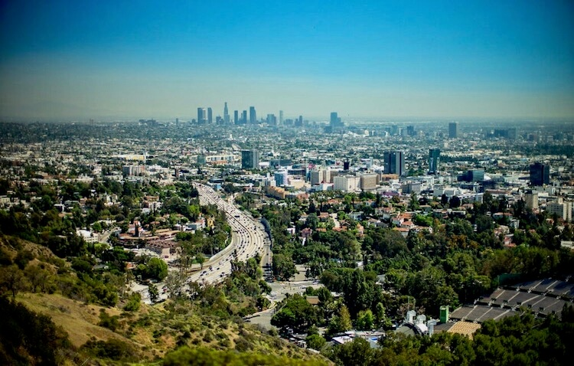
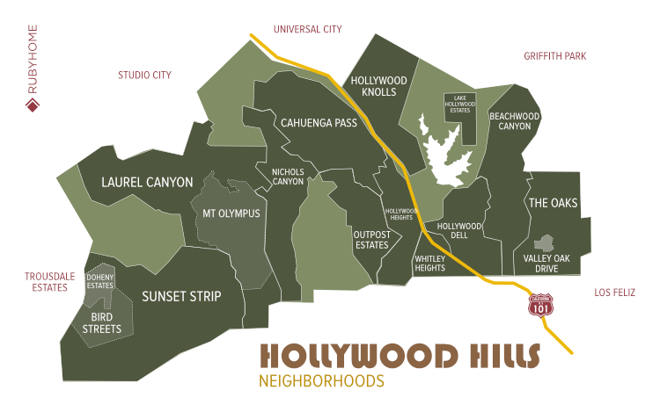
The life in Los Angeles is not only said to be good by the people who live in the area but also perceived by other people who visit this area. As a matter of fact, there are some people who have just heard stories about Los Angeles and strongly believe that this place is actually the same way that most people talk of it (Portacolone, Perissinotto, Yeh, & Greysen, 88). During the day time, when the sun is shining, Hollywood offers an aesthetic view that is loved by many people. It is a beautiful scene that nature lovers will prefer so much. The Hollywood hills provide an escape from the big city of Los Angeles bustle and hustle as the sun rays reach during the day. If you are tired of the city bustle and hustles, then you can just to the hills, take your time to relax and enjoy every bit of it. The city may be with some noise especially in the areas where we have the industries as characterized by all cities, but an individual can take a short break, walk towards the hill and get engrossed in the beautiful scenery.
At night, life in Hollywood appears to be even better. There is so much that people can enjoy during the night. As many people commonly know that for an individual to have a fun night, then they must go for night parties and restaurants, this is not only the case in Los Angeles. Without getting drunk and walking for parties in the busy restaurants and clubs in Los Angeles, you can walk out of your house and enjoy watching the nature under the sky (Baldassare, Sears, Butler, & Morrison, 11). An individual can enjoy a beautiful glow of stars above the hills and how they form a dorm shaped horizon above the hills. These are captivating beautiful natural scenery that can be watched over and over and ease an individual’s mind into endless space.
There are different types of people living in Los Angeles, and this brings a high level of diversity of the residents in this area. Sawhney, Deepak Narang argue that people who converge here are from different origins and cultural backgrounds. Even though people from different backgrounds inhabit the area, this difference has not many problems (Sawhney, Deepak Narang 15). As obviously known that a city with different people from different backgrounds and cultures will have a different lifestyle, this has been witnessed in Los Angeles (Baldassare, 4). The hills are dotted with different types of home ranging from funky bungalows to trophy mansions. The fact is that the homes exist in different sizes and architecture to which an attractive lush environment surrounds each home. This is a type of environment that portrays the real green nature as it has trees, grasses, flowers, and even shrubs.
Moreover, Hollywood is ranked as the place with the most powerful people in the entertainment industry. Hollywood has contributed so much in the entertainment industry. This is in terms of film making, where Hollywood has been making some of the best movies in the world. Hollywood is best known in the entire world for the production of movies. This is where some of the most famous actors have built their careers and still live there. This place has some of the most adorable celebrities in the world both in film and music sector. Some of the most famous celebrities who live in Hollywood are Marilyn Monroe, Frank Sinatra, Mila Kunis, Johnny Depp, Katy Perry, Kelly Osbourne and Chris Brown who also used to own a 3,000 square feet condo in West Hollywood.
Due to all the good things that are known about Hollywood and Los Angeles, people have always thought of this place to be a land flowing with milk and honey. Los Angeles has portrayed itself so much in positive ways. It is a land that has been regarded to have numerous opportunities and also wealth. The opportunity that most people are thinking about may be derived from the fact that it is the leading film producer in the whole world. Hollywood movies are so many, and they have been supplied to entertain people in different parts of the world (Sampson, Schachner, & Mare, 43). Therefore, people have thought that due to the high number of films produced in this area, there may be many opportunities for any person who travels there. Apart from entertainment that Los Angeles is widely known for, there are also other industries and businesses are booming so much in this area. The population is also considerably high and this has made some people believe that there enough people to provide various services to. The city has been very good at hiding most of its imperfections by showing a completely different reality (Lynch, 33). Los Angeles in Hollywood is a city where the catastrophic extremes coexist seamlessly. This is from urban uprisings to gated society, from natural disasters to climatological paradise, from internal Third Worlds to the central zones of the First world.
Los Angeles is the city of unmitigated contradictions in Hollywood. The city has beautiful houses and ubiquitous malls, but from the look of its landscape, a different ideology may be derived from how its geographical features are made. The landscape of this city reveals much, more than asphalt that has been cracked. The landscape of Los Angeles portrays a choreography of two forces that are opposing each other. It can be said to describe various good and bad things that happen in Los Angeles (Burke, Greene, & McKenna, 45). For instance, it portrays colors of hatred of whites versus blacks, the tension of good versus evil, the high rates of inequality between the wealthy and the poor, and many more. First things are just overhyped about Los Angeles. Since there are many celebrities in Hollywood, one might tend to think that they can bump on some celebrities while driving or walking. Well, this is a different case, you might spend even more than a week if you are a visitor and finally walk out of the city without seeing any celebrity.
Lawson, et al. argue that overhyping is not only about the celebs but also the structures that are found within the Hollywood in Los Angeles (Lawson, 9). One is that has been overhyped is the Rodeo Drive. It is not that the street is not good, but it is the fact that the street is overhyped by people. The way people usually talk of how you will have to stop at the Rodeo Drive makes it into a massive experience, but when you arrive there, it is just a shopping street filled with shops like any other (Salvo, Lashewicz, Doyle-Baker, & McCormack, 90). To add, the cafes within the city are just okay, but some of them look a little seedier. This is the same thing that applies to some restaurants, pubs, clubs and fun joints, especially in downtown. These are places that you will find to be dirty and not well-kept. The people who would be found there are unreal, but the area will still appear to be buzzing with activities. These are groups of people who are dirty and do not care so much about taking good care of themselves.
Furthermore, crime has been on the rise in Los Angeles. According to Wayne, the rate of crime in Hollywood has been recorded to be very high compared to other regions in the United States (Wayne, 13). The overall rate of crime in Hollywood is 100% higher than the national average. This is for both of the crimes when they have been tallied together, including homicides, violence, rape, property, and cybercrime (Masuda, & Bookman, 8). It has been reported that for every 100,000 individuals, there are 15 daily crimes which take place in Hollywood. Despite the measures that have been employed in this city, there are still many crimes taking place, and the rate is even increasing. This is justified by the fact that there has been a 10% increase in the number of years.
In conclusion, Hollywood is more exaggerated than how it is perceived in reality. It is very true to say that Hollywood is immensely different from expectation versus reality. People think of Hollywood as a place that is full of opportunities, wealthy and safe (Historical Geography, 66). This is from the fact that many celebrities live there and develop their careers into stars from the same Hollywood. The film and music industry has also made it very famous and appear perfect. However, this is not the case the rates of crimes are very high in Hollywood, and this has been increasing by some percentage over the past years.

Works Cited
Wayne, Gary. “Hollywood Boulevard.” Hollywood Boulevard - Myth & Reality, 2019, www.seeing-stars.com/Streets/HollywoodBlvdMyth&Reality.shtml.
Sawhney, Deepak Narang. "Journey Beyond The Stars." Palgrave Macmillan, 2002, pp. 4.
Lawson, Richard. “Reasons to Love Hollywood Right Now.” Vanity Fair, Vanity Fair, 15 Jan. 2014, www.vanityfair.com/hollywood/2014/01/5-reasons-to-love-hollywood.
Kingsley, G T, Claudia J. Coulton, and Kathryn L. S. Pettit. Strengthening Communities with Neighborhood Data. , 2016. Print.
Historical Geography. Northridge, Calif: Dept. of Geography, California State University, Northridge, 1978. Print.
Portacolone, Elena, et al. "“I feel trapped”: The tension between personal and structural factors of social isolation and the desire for social integration among older residents of a high-crime neighborhood." The Gerontologist 58.1 (2017): 79-88.
Graham, Brian, Greg Ashworth, and John Tunbridge. A geography of heritage: Power, culture and economy. Routledge, 2016.
Masuda, Jeffrey R., and Sonia Bookman. "Neighbourhood branding and the right to the city." Progress in Human Geography 42.2 (2018): 165-182.
Salvo, Grazia, et al. "Neighbourhood built environment influences on physical activity among adults: a systematized review of qualitative evidence." International journal of environmental research and public health 15.5 (2018): 897.
Burke, Kevin J., Stuart Greene, and Maria K. McKenna. "A critical geographic approach to youth civic engagement: Reframing educational opportunity zones and the use of public spaces." Urban Education 51.2 (2016): 143-169.
Sampson, Robert J., Jared N. Schachner, and Robert D. Mare. "Urban income inequality and the great recession in Sunbelt form: Disentangling individual and neighborhood-level change in Los Angeles." RSF: The Russell Sage Foundation Journal of the Social Sciences 3.2 (2017): 102-128.
Baldassare, Mark, et al. The Los Angeles riots: Lessons for the urban future. Routledge, 2019.
Lynch, Kevin. The Image of the City. Cambridge, Mass: MIT Press, 1960. Print.

